* Chinmay Manchanda
* Contribution in the report by Team 3 of R2R project.

### Table of Contents

Introduction 3

Executive Summary 3

Problem Statement 3

Conceptual Design 4

Design Concept Generation 4

Design Concept Evaluation 4

Design Solutions 4

Design Considerations 5

Materials 5

Mechanical 5

Electrical 5

Computing 5

Financial 5

Final Design 6

Design Sketches 6

Design Details 6

Design Innovations 6

Appendices 7

Project Planning 7

Other 7

# Introduction

## Executive Summary

This report presents a design for an autonomous robot that is to be constructed which will be able to maintain a straight path whilst avoiding obstacles. The combination of caterpillar tracks and wheels enables it to maneuverer in both rough and smooth inclined planes without losing balance. The design presented in this report uses aluminium cans for the body. Using an ultrasonic distant sensor, the robot can avoid obstacles. An Arduino along with a 9V battery is used to power the motors. A pair of propellers are used to allow the robot to hover in the air. Microphone and speakers will be used for the alarm system. The entire design can be constructed under 120 dollars.

## Problem Statement

# Design and construct an autonomous rescue robot that is able to effectively complete a series of challenges. The total cost of manufacturing the robot must stay under 120 AUD. The robot must be able to maintain a straight path whilst avoiding any presented obstacles. It should be able to maneuver in both rough, and smooth inclined planes without losing balance.

# Conceptual Design

## Design Concept Generation

## Concept generation is the second phase of the design process and is critical to obtain a robust design. It is the process of exploring the different designs that can be implemented. Problems identified later during testing would have resulted in dismantling and rebuilding the structure. Therefore, identifying the final product’s requirements carefully is important at this stage, to save time and prevent iterations later. This process involves identifying the functions required in the device, ascertaining requirements and the means for achieving these functions. The next step is to generate design alternatives. The more ideas that come through at this stage, the better it is, as the most effective idea can be implemented - our team came up with ideas for caterpillar tracks, etcetera. which was a diverse range to choose from. Concept Generation stage helps grouping incomplete ideas together to build a more cohesive, well-thought out product that meets the client’s requirements.

## Design Concept Evaluation

The design presented in this report is very versatile and energy efficient. It is also very environmentally friendly since all the material used in the design is made from recyclable materials. It is autonomous because of the usage of a free programmed Arduino uno board. The robot can withstand drops since its body is made from sturdy, robust and light aluminium alloy body recycled from coca cola cans. The utilization of the pair of propellers on the top of the body is the highlight of the design. The pair of propellers allow it to hover in the air and avoid obstacles in an innovative way. The addition of a microphone and a speaker allow us to send message to the people buried in the ruins of the building from earthquakes or fires. The ultrasonic distance sensor can detect precisely and accurately the distance between the obstacle and the robot so that the robot can change its direction to avoid the obstacle.

## Design Solutions

For the design solutions, we have come to agree on several potential designs, each having its own advantages and disadvantages. Our first design solution was to design a very compact sized robot with one propeller point and four wheels. We then realised that the fewer number of wheels may result in the robot not turning effectively and less grip because there was no caterpillar track. For our final design, we decided to add more wheels to increase the turning motion. Furthermore, we also included a caterpillar track which will result in a better grip and a more well balanced robot.

# Design Considerations

## Materials

For the wheels of the robot, we decided to go with two kinds of wheels: the support wheels at each end of each caterpillar track and the non-supporting wheels at the center of each caterpillar track. For the supporting wheels, we decided to use rubber tires with a diameter of 45 mm and a thickness of 10mm. the surface of the tires are relatively rough compared to normal tires to give a larger rolling resistance so that the wheels can fit perfectly with the caterpillar tracks. For the non-supporting wheels, the diameter shall be slightly smaller than the diameter of the supporting wheels, which would be 40mm with the same thickness of 10mm, meanwhile the wheels’ main function is to assist the supporting wheels when it comes to turning and altering the robot’s course.

In our design, caterpillar tracks are used around two sets of the wheels to give a better gripping ability to the wheels so that the robot can move steadily when it functions on uneven and rough terrain, instead of a set of linked steel plates, the caterpillar tracks are made of reinforced rubber plates as they’re lighter and gives a larger friction, also it makes turning around easier when sharp corners are encountered.

For the body of the robot, initially we are going to use recycled aluminium cans as it’s environmentally friendly and more cost-efficient and it is easy to assemble the cans into a desired shape and size and when the material can get brittle when overly bent. It is a cheap alternative as we can still manage to keep the whole design within budget.

## Mechanical

## Robots must be enforced to transfer motion from the engine to a part. This is completed by belts and pulleys that transmit torque. Robots will adopt either of these types of belts: • Round belts • V-belts • Flat belts • Toothed belts

## Gears and chains operate on the same mechanical principle as pulleys and belts: making use of turning motion to transmit torque. Gears can develop speed, force or alter the direction of a force. While cars have several gears, the main ones are those that transfer power from the crankshaft (the rotating axle powered by the engine) to the driveshaft (the shaft under the car that turns the wheels).

## In robotics, gears do the job – transmitting motion from one part (often the engine) to another (often the moving part). The ratio between the number of teeth on the input or driven gear and the output gear is how the torque and speed of the output gear can be calculated. So, when constructing a robot, robotics teams and innovators should decide gear size and number of teeth based on the wanted output speed and the known input speed. This is all based on the approach of mechanical advantage.

## To begin the motion of the robot, in robotics wheels are favoured when speed, accuracy and stability are all needed. Wheels can be standard, ball, and omnidirectional with the basic goal to move the robot from one place to the next. In a robot, wheels may be normal, oriental, ball, and position with the elemental goal to plot the mechanism from one place to another. Robots with differential wheels move based on the motion of two solely driven wheels on either side of their body, changing the direction by differing the speed of rotation of each wheel alone.

## Electrical

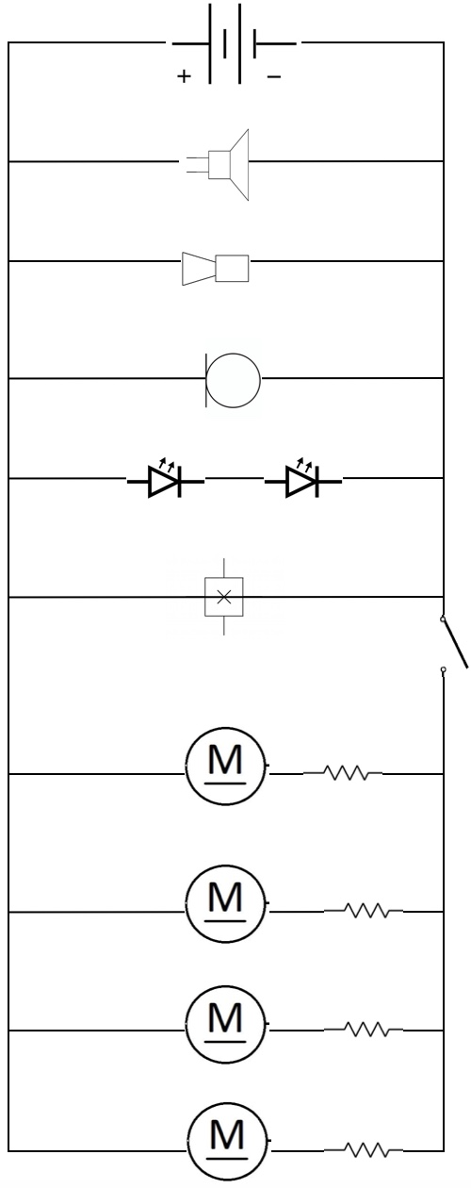

The diagram above displays the overview of the electrical circuit that will be used in our robot, it is labelled with parts that will lie within the circuit. We have a switch to the motor as this is the only component’s electrical flow we must control, whereas the other components will remain on (constant electrical flow).

## Computing

Recent advances in technology have brought many benefits and changes to our society. As the software behind this technology becomes increasingly complex, humans can rely on the automation of tasks that would otherwise require much time and effort. Computing part focuses on putting the microcontroller and other important hardware into use. Other hardware’s include: Motor controller, ultra-sonic Distance Sensor, FPV camera’s and Speakers (which may or may not be included in the final prototype).

Most of the coding part in microcontroller is done with the help of Arduino and our faculty has given us some important codes which just require small changes. The role of the computing stream after making it functional is to think of innovative ideas and apply them. We plan to use FPV cameras to send live feed with the help of the robot in situations in which it is impossible for a human to possibly reach. Also, this will help the medical crew to identify the problem faced by the victims in those situations.

Also, according to our plan there will be a speaker and a microphone so that our robot could do various task such as triggering an alarm, or dictating the exit way to the victim or a possible solution in that specific situation. Half of this will be done by the codes available on the Arduino website and out innovative ideas will be completed by the research of the computing and electrical stream.

Coding on Arduino is based on either c++ or c. Everything in the code works on the circumstances. For example, an if loop is present in the code, which acts when the ultra-sonic distance sensor senses a wall within 100 centimetres and the code commands to **“stop”**. This command **“stop”** works and stops the motors which ultimately stops the robot.

Now changes can be made like if we want to make the robot turn right or left, we can freeze the motor of the opposite wheel side so that the robot starts turning in our desired direction. Again, all these commands are given in **“while or for”** loops till our wanted **“if”** condition is fulfilled.

For example, suppose that our robot has 3 ultra-sonic distance sensors placed at 90 degree to each other. In this situation, our robot goes through a maze and senses a wall in front of it. If this happens the work switches over to the other sensor which senses if there’s a wall on it’s right, if not it is commanded to move towards right at 25% or 50% speed. But if there’s a wall on right too, the work switches off to the third ultra-sonic distance sensor which does the same work. All these functions are coded by our computing stream with the help of ARDUINO IDE.

There are a few exceptions that we’ll cover such as what if there’s a wall on all three sides but there’s a way which is at 45 or 135 degree to the robot’s front. In that case, we have a specific code which rotates the distance sensor at the front by 75 degree’s to both the sides so that if it senses more distance at any other angle than it did sense before, it can move towards that angle.

## Financial

* Wheels – $2 each ( 6 wheels will be used ) = $12
* Body - Recycled Aluminium ($0.5 per Kg) = NULL
* Arduino – $17(Provided to us) – $7-8 (Our Source)
* Motor Controller – $2.56
* Breadboard – $1.5
* Fpv Camera – $7
* Speaker – $3.5
* Microphone – $1
* Battery – $2.46 (each)
* Wires and bulbs and resistors – $8-9
* Flashlight - $4-5
* Ultra Sonic Distance Sensor – $1.5 Not Finalised (Planned after the completed a fully functional robot)
* Propellers – $8 ( 4 pieces)
* Chassis – $10

# Final Design

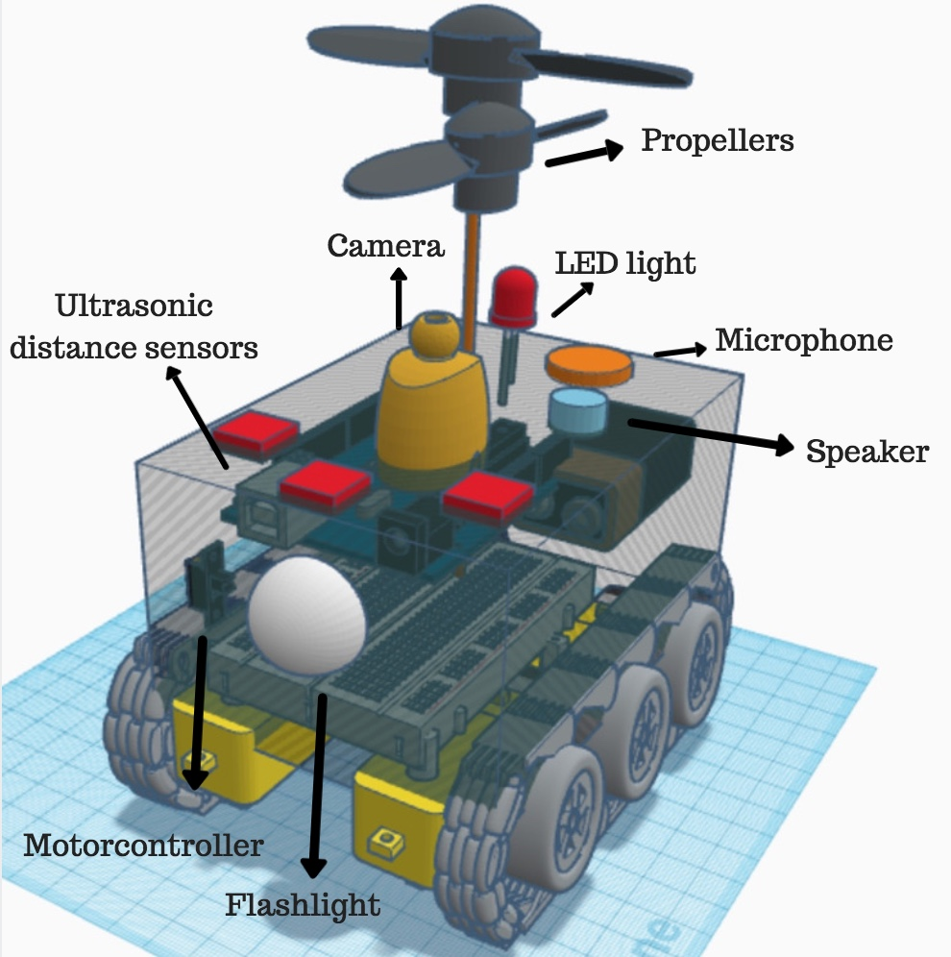**Design Sketches**

## 

## 

## 

## Design Details

From the sketches, we can see that each wheel set consists of 3 wheels and one wrapping-around caterpillar track. The two supporting wheels are placed at each side and one non-supporting wheel is at the center, the lying-flat wheel sets are 25mm apart from the body of the robot while each wheel is connected to the body by a stick that is fixed on one end (the end that connects the wheels) but free to move on the other end (the end that sticks inside the robot) so that when the robot encounters sharp corners the sticks can move freely to change the directions of the course.

The distance between each wheel is 10mm as this way the rough-surfaced wheels won’t impede each other. The lying-flat wheel set and the inclined wheel set are connected by one common supporting wheel, the inclined wheel sets are designed to work on inclined and uneven surfaces as it helps the robot to transit smoothly from a flat surface to an angled surface, it also in some way prevents the robot from being flipped over when large obstacles need to be avoided.

The size of the box is set to be 150*100*100 in mm, this is the smallest size for all the sensors, breadboards, chips, circuits and speaker to be fitted in perfectly and for the robot to also remain efficient. The detailed measurements of the challenges are still unknown, so this is a reasonable estimation that was made regarding the function and flexibility of the design.

## Design Innovations

Innovation can simply be defined as a ‘new idea, device or method’, however it can also be viewed as an application of better solutions that meet new requirements and needs. When designing our autonomous robot innovation is a significant factor that we must incorporate, this is to allow our robot to be better regarding its own design but also to stand out over the other designs. We have included many components into our robot which we believe carry’s the essence of innovation with it. One of the components we have decided to factor in is a, fire proof body. Making the body fire proof is innovative as these robots must manoeuvre through various courses used to simulate a real-life disaster situation, and in a real-life situation, fire hazards are a very real possibility. We are choosing to use aluminium for our body which has 4 times the heat conductivity of iron, making it fire-resistant. However, to reinforce this we have also chosen to spray the body in a fire-resistant spray. We have also gone ahead and added a microphone, camera and speaker. These innovative components will allow us to communicate with the individual that is requiring assistance in this emergency. The camera will allow us to get live-time view of the situation from the perspective of the robot, and the microphone will allow the robot to detect any audio or messages that the individual may have, while the speaker will allow us the users, to convey audio through the robot. Finally, we have also chosen to add a flashlight, this will allow the robot to adapt to the situation regardless of the lighting

# References:

# [Waldrum](https://www.thezebra.com/insurance-news/author/jwaldrum/), J 2017, ‘Automotive Machines and Design Principles for Robotics Teams and Future Engineers’.

**Appendices:**

|  |  |  |  |  |  |  |  |  |  |  |  |  |  |
| --- | --- | --- | --- | --- | --- | --- | --- | --- | --- | --- | --- | --- | --- |
| **ENGG1000 PROJECT MANAGEMENT CHART** | | | | | | | | | | | | | |
| **Activities** | **Week 1** | **Week 2** | **Week 3** | **Week 4** | **Week 5** | **Week 6** | **Week 7** | **Week 8** | **Week 9** | **Week 10** | **Week 11** | **Week 12** | |
| **Engineering** |  |  |  |  |  |  |  |  |  |  |  |  | |
| Brainstorm & Analyse Problem |  |  |  |  |  |  |  |  |  |  |  |  | |
| Create Problem Statement |  |  |  |  |  |  |  |  |  |  |  |  | |
| Research on Individual Technical Streams |  |  |  |  |  |  |  |  |  |  |  |  | |
| Create Design Solutions & Sketches |  |  |  |  |  |  |  |  |  |  |  |  | |
| Explore Design Options |  |  |  |  |  |  |  |  |  |  |  |  | |
| Concept Generation Presentation |  |  |  |  |  |  |  |  |  |  |  |  | |
| Narrow Down Design Choices |  |  |  |  |  |  |  |  |  |  |  |  | |
| Final Design Choice |  |  |  |  |  |  |  |  |  |  |  |  | |
| Design Proposal |  |  |  |  |  |  |  |  |  |  |  |  | |
| Design Report |  |  |  |  |  |  |  |  |  |  |  | |  | |
| **Activities** | **Week 1** | **Week 2** | **Week 3** | **Week 4** | **Week 5** | **Week 6** | **Week 7** | **Week 8** | **Week 9** | **Week 10** | **Week 11** | **Week 12** | |
| **Construction & Testing** |  |  |  |  |  |  |  |  |  |  |  |  | |
| Gather Materials |  |  |  |  |  |  |  |  |  |  |  |  | |
| First Iteration- Construct Robot |  |  |  |  |  |  |  |  |  |  |  |  | |
| * Arduino Programming |  |  |  |  |  |  |  |  |  |  |  |  | |
| * Connecting Circuit |  |  |  |  |  |  |  |  |  |  |  |  | |
| - Assembling Robot Together |  |  |  |  |  |  |  |  |  |  |  |  | |
| Preliminary Testing |  |  |  |  |  |  |  |  |  |  |  |  | |
| Reflect/Brainstorm on Failures & Changes |  |  |  |  |  |  |  |  |  |  |  |  | |
| Second Iteration- Further Construction |  |  |  |  |  |  |  |  |  |  |  |  | |
| * Insert Advanced Features to Robot |  |  |  |  |  |  |  |  |  |  |  |  | |
| * Sensor, Microphone Assembly |  |  |  |  |  |  |  |  |  |  |  |  | |
| Final Testing |  |  |  |  |  |  |  |  |  |  |  |  | |